FPGA DESIGN AND IMPLEMENTATION REPORT
(Write the name of your digital system here)

1) Design description.
- Write a description of the digital system and its behaviour.
- Fill in a table for each significant circuit of the digital system you are describing and for the top file, with the following information:
Write the name of your circuit here (file_name.vhd)
begin

an0 <= s2;
an1 <= s3;
an2 <= s4;
an3 <= s5;

MMUX : MUX Port Map (sel => s8,
e1 => ent1,
e2 => ent2,
e3 => ent3,
e4 => ent4,
S => s1);

DDEC : Entrada_dp_in Port Map (an0 => s2,
an1 => s3,
an2 => s4,
an3 => s5,
d => dp_in,
q => s7);

ENDP : Decoder_1a4 Port Map (G => '1',
d => s8,
q(0) => s2,
q(1) => s3,
q(2) => s4,
q(3) => s5);

LLED : Leds_7_Segs Port Map (DIN => s1,
dp_in => s7,
en => '1',
DP => dp,
S => S);

DDIV : Divider1000 Port Map (clkin => clk,
reset => reset,
clkout => s6);

CCON : Cont_2b Port Map (reset => reset,
clk => s6,
ce => '1',
load => '0',
din => "00",
q => s8);

end Behavioral;
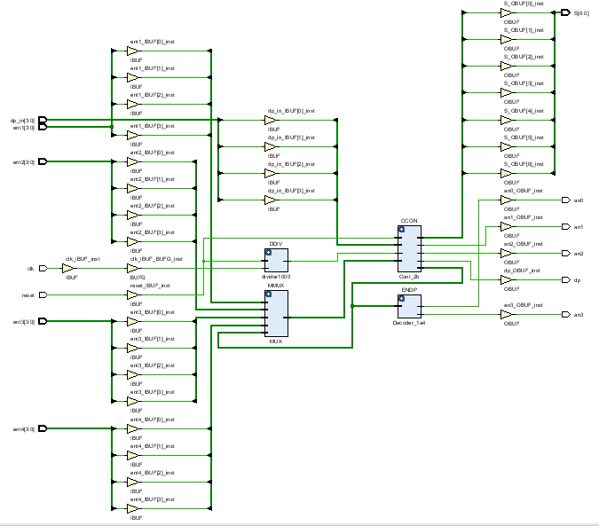
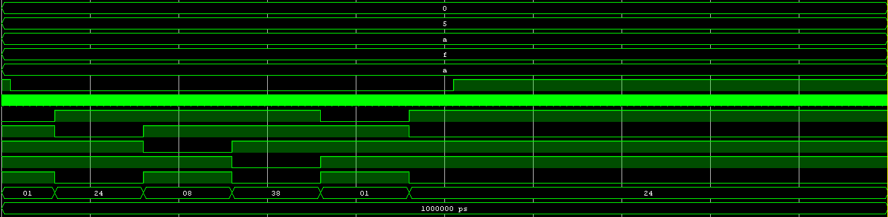

2) Implementation analysis.
FPGA: XC7A35T-CPG236-1 C
2.1. FPGA resource analysis:
 | Slices (total) | Slice LUTs | Slice Registers | Bonded IOBs
Visualizador | 9 | 24 | 12 | 34

2.2. FPGA timing analysis (only for sequential circuits):
 | Setup  Worst Slack | Hold Worst Slack | Min. Clock Period | Max. Clock Frequency
Visualizador | 7,545 ns | 0,213 ns | 2,155 ns | 464 MHz

3) Conclusion.
Explain if everything has worked as expected, if the FPGA resources used and the final delays are correct, and any other special circumstance worth mentioning.

